# Data Preparation and Exploration:

# *Overview*

In this story, through data analysis and visualizations I will explore if Congress was able to control inflation and maintain low unemployment. For this, I have downloaded the Consumer Price Index (CPI) from the Bureau of Labor Statistics (<https://beta.bls.gov/dataViewer/view/timeseries/CUSR0000SA0>) excel file, the FED Funds Rate (FRED) from the Federal Reserve Board (<https://fred.stlouisfed.org/series/FEDFUNDS>) excel file and the Unemployment Rate from the Bureau of Labor Statistics (<https://beta.bls.gov/dataViewer/view/timeseries/LNS14000000;jsessionid=1EFB037000DD042BF4B9B5594DF83E80>) excel file. The data in each of the files represents data from the past 25 years (1998 – 2023). The main question I will answer through my visualizations is: “Has the FED been able to fulfill the mandate given to it by Congress?” I will utilize excel to perform this analysis.

# The first step I did is consolidating all three excel files (data sets) into one excel workbook. After this is done, I will get the following:

# *CPI Data Set:*

# 

# The CPI index data set shows the U.S. city average CPI for all urban consumers for all items which is seasonally adjusted. It is measured as the average change over time in the price paid for the consumer goods and services.

# *FED Funds Rate Data Set:*

# 

# The Federal Funds Rate is the target interest rate at which commercial banks borrow and lend their excess reserves to each other particularly overnight. The Federal Funds Rate numbers in this data set are not seasonally adjusted.

# *Unemployment Rate Data Set:*

# 

# The unemployment rate includes all industries, occupations, races, sexes and educational levels. If individuals above the age of 16 and are ready and willing to work. It is measured as the percent of rate.

# *Data Cleaning*

# I will now perform data cleaning to the data sets which I believe need cleaning.

# *CPI Data Set:*

# For the CPI data set I will perform the following:

# Remove the “Year” and “Period” columns since they are irrelevant to our analysis

# Rename “Label” column to “Date” and “Observational Value” to “CPI” since these descriptions better fit the values in the column

# I will change the Date column to a common format: month/day/year

# After this has been done, I will get the following:

# 

# *Unemployment Rate Data Set:*

# For the Unemployment Rate data set I will perform the following:

# Remove the “Year” and “Period” columns since they are irrelevant to our analysis

# Rename “Label” column to “Date” and “Observational Value” to “Unemployment Rate” since these descriptions better fit the values in the column

# I will change the Date column to a common format: month/day/year

# After this has been done, I will get the following:

# 

# *Descriptive Statistics*

# I will now perform descriptive statistics on each of the three data sets to better understand the relationship between the variables.

# 

# *CPI Data Set FED Funds Rate Data Set*

# 

# *Unemployment Data Set*

# 

# Data Analysis:

Before proceeding to analyzing the data through the construction of visualizations it is important for me to gain some domain knowledge which would help me answer the question: “Has the FED been able to fulfill the mandate given to it by congress – that is to control inflation and to maintain low unemployment ?”. More concretely, I would need to understand the meaning of the data behind the three data sets as well as the relationship between the data within the three data sets (CPI, Fed Funds Rate and Unemployment Rate). Having this knowledge will empower me to tell a better story and answer the question at hand.

***Domain Knowledge***

The CPI index are a group of indexes that measures the price change of the average change over time paid by urban consumers. The federal funds rate is the target interest rate set by the Fed at which commercial banks borrow and lend extra reserves to one another overnight. In simple terms the unemployment rate is the percentage of the total labor force that is unemployed but seeking and willing to work. The next step is for me to understand the relationship between the CPI Index, Federal Funds Rate and Unemployment Rate. As the CPI decreases (price decreases from the base year) inflation will also decrease. In consequence of lower inflation leads to higher unemployment because people are not working and have less purchasing power. An increase in the Federal funds rate also leads to a decrease in inflation because as borrowing costs increase the demand for goods and services will drop. The following equation summarizes the relationship between the CPI Index, Federal Funds Rate, Unemployment Rate and Inflation:

**Higher CPI = Higher Inflation = Lower unemployment = Lower Federal funds rate**

***Data Visualizations***

***Visualization(s) # 1***

The first set of visualizations I will build are three-line charts to compare the change of all three variables (CPI, FED Funds Rate and Unemployment Rate) individually over the past 25 years. Each line chart will be placed inside their respective tab in excel.

*CPI Line Chart*

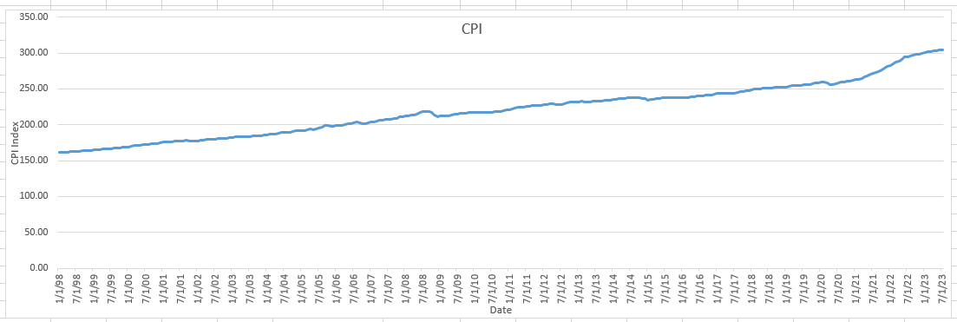

*Fed Funds Rate Line Chart*

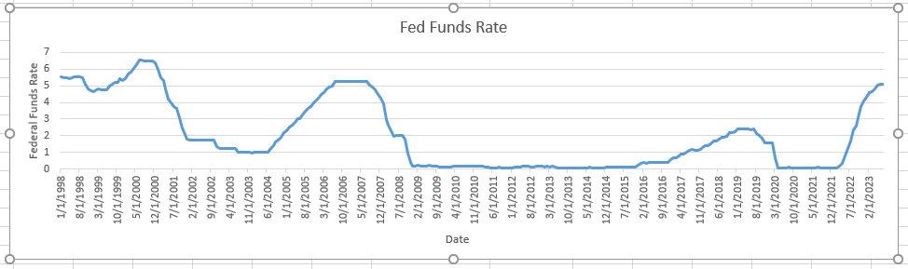

*Unemployment Line Chart*

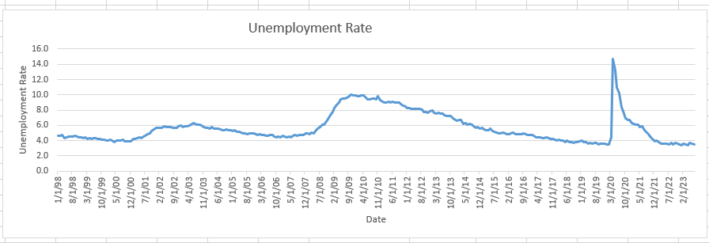

***Analysis***

The CPI line chart shows a relatively upward change in the CPI over the course of the 25-year period. This indicates an increase in consumer prices which in turn indicates higher inflation. The next line chart we look at is Fed Funds line chart to see how the fed tackled this inflation over the course of the 25-year period. Based on what we know, the higher the fed raises this rate the more demand for goods and services, the more inflation will drop. Looking at the Fed Funds line chart we see that at times when there was a higher bump in inflation (notably from 2004 to 2008), there was also a substantial rise in the fed funds rate during this period. To me this indicates that the fed made an effort to counter inflation. The next question which follows is: Was unemployment relatively stable during this period of bump in inflation (2004 to 2008)? Looking at the Unemployment Rate line chart, we can tell that the unemployment rate was in fact between 4 to 6 percent which is relatively ok. It’s also interesting to look at the time frame of 2010 to 2015. We see that during this 5-year interval unemployment dropped from 10% to 6% and the Federal funds rate stayed virtually constant with the CPI increasing at a constant rate. The Fed not increasing with the Fed Funds rate indicates resulted in a decrease in unemployment while inflation grew indicates that the fed is trying to fulfill their mandate.

***Visualization(s) # 2***

The next visualization I will build is a double line chart to try and observe the relationship between the Fed Funds Rate and the Unemployment Rate. I want to take a closer look at the at the Fed’s reaction to an increasing unemployment rate at certain time frames during the course of the 25-year period. The double line charts will be placed inside the “Double Line Chart” tab.

***Analysis***

The first-time frame I want to observe on the double line chart is from 1/1/2008 to 1/1/2010. We see that the unemployment rate has increased. In this time period we see that the federal funds rate drops and becomes constant. This drop off would propel inflation to go down. As a consequence, to this action we see unemployment gradually drop from 2010 to 2019. Another interesting time frame I want to look at in this graph is from 2020 to 2023. We see that at the height of the pandemic the unemployment is high and thus the federal funds rate is not touched, but as unemployment goes down from 2021 to 2023 the fed raises the federal funds rate which would increase inflation. These actions further show that fed is trying to control inflation while still trying and maintain low unemployment.

***Visualization(s) # 3***

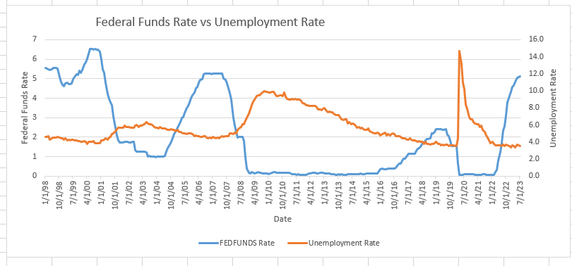

The next visualization I will build is a scatter plot to try and observe the change between the CPI and Federal funds rate variable in order to see how often the fed reacted to inflation. In other words, if as the CPI increase, does the FED lower the federal funds rate in order to maintain unemployment.

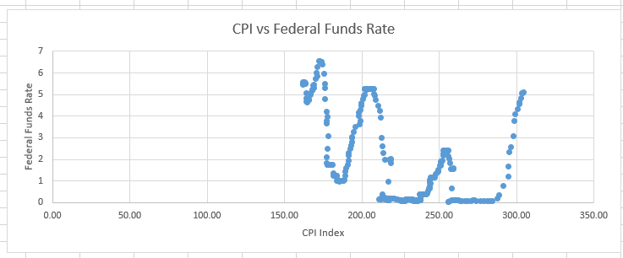

***Analysis***

From the Scatter plot above, for the most part we see that as the CPI index (inflation) gets higher the fed will increase the federal funds rate to increase the cost of borrowing.

***Visualization(s) # 4***

The final visualization I will build is a scatter plot to try and observe the change between the CPI and unemployment rate variable in order to see the relationship between the two variables. In other words, is their stability between the unemployment rate and inflation.

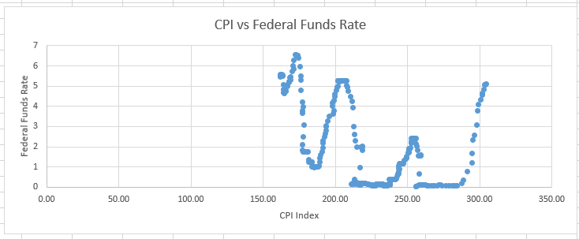

***Analysis***

From the scatter plot above, we can see that as inflation increases unemployment decreases. The changes seem balanced for the most part. There are a few outliers which show a large increase in unemployment rate with a constant CPI.

***Conclusion***

In conclusion, we could see that the Fed does in fact try to control inflation and

maintain low unemployment.